DocNo: 001.C.1:1

Bug Tracking
Requirement Analysis Document
Version 2.0

By:
Twister Group
2003-07

Group Member:
Bob
Jalin
Mario
Roger
Minerva

Document Language:
English

Revision History
Date | Version | Description | Author
2003-7-10 | 1.0 | Finish the architecture of the document | Us all
2003-7-11 | 1.0 | Do assigned part respectively | Us all
2003-7-12 | 2.0 | Checkout | Minerva, Roger
Final date | <x.x> | <details> | <name>

Key Word
BTS
Bug
Bom
Functional
Non-functional

Abstract
This document is the important for our BTS project, since it will define most of the requirement for this system. We describe not only functional but non-functional requirement as well. And give a specific hardware and software environment, and other necessary information for our system.
Table of Contents
1 Introduction 4
1.1 Purpose 4
1.2 Definition 4
1.3 Reference 4
2 System Overview 4
3 Detailed System Requirements 5
3.1 Functional Requirements 5
3.1.1 Functional/Behavioral 5
3.1.2 Non-Functional 5
3.2 Integration Requirements 5
3.2.1 Integration Requirements Document 5
3.3 Architecture Requirements 6
3.3.1 Computing Platforms 6
3.3.2 Network Infrastructure 7
3.3.3 Operational Requirements 7
3.4 User Interface Requirements 7
3.4.1 Screen Layout 7
3.4.2 Reporting 8
4 Requirements Analysis Models 8
4.1 Functionality (behavioral) 8
4.1.1 Use Cases 8
4.1.2 Functional Analysis Model 8
4.2 Architecture & Bill of Materials 8
4.3 User Interface 10
4.3.1 Login interface 10
4.3.2 After a user is login 10
4.3.3 Administrator operation interface 11
4.3.4 Project create and edit form 11
4.3.5 Bug report form 12
4.3.6 Bug edit form 12
5 Requirements Traceability 12
6 Build/Buy/Reuse Rationale 13
6.1 Reuse Criteria 13
6.2 Rationale 14
7 Requirements Dependencies 14

- Introduction

Purpose
This is a requirement specification document. In this document, we will define most of the system requirement, so that all the develop team member can have a clear picture of the whole system. We define not only the functional requirement, but the non-functional requirement as well. This is the main document of this define phase, in this phase, we also have glossary document, use case specification document and we offer a prototype.

Definition
BTS: Bug Tracking System
Twister: our develop group
Bom: bill of material
Functional: some requirement that need to be realized
Non-functional: some requirement that cannot be realized but is indispensable to our system

Reference
Wicrosoft BMS System White Book
Bob Hughes and Mike Cotterell 《Software Project Management》

- System Overview
During the phase of software development, there exist large amount of bugs. The old method we use is to deal all these bug management work manually, which is time, recourse and labor exhausting. On the other hand, since there are many users want to report all kinds of bugs, this kind of management is just somewhat ineffient.
Therefore, a network-based bug management system BTS is being called out. The programmers and tester can work with this distributed system effectively; of course do the job anywhere they like. With this computer-aimed system, tester and programmer can not only find and report the bugs systematically, but track their states easily as well, so that less bugs well be neglected. It will help the developer to manage Bugs more easily and more effectively.
We have following functions
Administrator:
- Create a Project: Add new unverified the project to the BTS and builder a team and Bug management criteria.
- Edit a Project: Modify a the project such as personnel adding and deleting
- Close a project: When a project finished, do some garbage collection job.
General Users
- Project manager: can open a bug and manage the whole project
- Tester: report a bug and give modify suggestions
- Developer: fix a bug
Other non-functional requirement
- The bugs state must be traced and managed
- There exists different privilege for all kinds of user
- Security affairs
- And Statistics must be made
- Detailed System Requirements

Functional Requirements

Functional/Behavioral
BTS provides users a powerful tool to organize and manage bugs reported by software engineers.

First of all, it can help team members report the bugs they find in a uniform format, in the way that everyone else in the team can view the description of the bug easily and clearly, and make sure bugs are properly stored.

Bugs can be assigned to somebody to request for fixing. BTS should provide a mechanism to ensure the “bug receiver” is reformed on time that a new bug is assigned to him/her. And the authority of assignment a certain bug is related to the severity of the bug, for example, generally, high severity bugs can only be assigned by PM, and low severity bugs can be assigned by tester directly to developers.

During the life cycle of bug, team members need to add or modify the modification of bugs. Generally, the modification of a bug can be divided to several parts, including report information, fixing details and verifying information and so on. Different roles have the authorization of editing the different parts of the bugs.

With BTS, team members should be able to search the new bugs reported by others, which is assigned to him/her, and check it one by one in detail. Any user can be clear what’s his job and arrange the schedule properly according to the tasks listed by BTS.

BTS also provide a powerful and convenient service to project managers, who want to have a big picture of the project development. Project managers can use the analysis and statistics tool to take a graphical view of how many bugs are found, fixed, or closed respectively in a certain period of time, and which testers have found most bugs, and so on. Those kinds of data present not only the bugs information but also important things about the project itself. This is a useful and powerful tool for Project managers or administrators to be aware of how the project is going.

Non-Functional
Bug information should be accessed by team members quickly and safely. No data lost are permitted.

Special security measurements are need to make sure only valid users can log into the system, view the bug’s information about the specified project.

Integration Requirements

Integration Requirements Document
An external database system is required .The database is the company’s people information database. Our system interacts with this database system and pick up the people information, which is needed. And we store them into our own people information database in our system.
Just the some of the staff information that make sense in our system are needed to pick up, such as name, ID, email address, password, telephone number.

Architecture Requirements

Computing Platforms
Database server:
CPU: Pentium IV 1.3Ghz or better
Main memory:
Minimize: 512MB recommendation: 740MB

Application server:
CPU: Pentium IV 1.3Ghz or better
Main memory:
Minimize: 512MB recommendation: 740MB

Client:
CPU: Pentium Ⅱ 800Mhz or better.
Main memory: 128MB or more.

Software Requirement:
Operating System | Windows 2000 Server (recommended), or  Windows NT 4.0 Workstation or Server, or  Windows XP Professional (this platform only recommended for use with Problem Tracker for evaluation purposes only since this is not a "server" platform, this platform is not supported for use with Oracle 8i or 9i)
Web Server | Webshpere Application Server or  BEA weblogic 6.1 or .Net framework
Database | Microsoft SQL Server 7.0 or 2000, or  Oracle 8i or 9i or  DB2

Software general architecture

Database server (DB2 or others).

Application server (Websphere Application sever)

Client (Web Browsing such as IE)

Client (Web Browsing such as IE)
Client (Web Browsing such as IE)
Client (Web Browsing such as IE)

Network Infrastructure
B-S network Infrastructure is required.
A brief network infrastructure required can be show as follows:

Operational Requirements

Performance
The system response time (response to users’ request from servers to clients) must less than 20 second, if the network state is normal.

Reliability/Uptime
The system must run normally always if the hardware has no problem.
The run-time errors appear every month should less than 5.
The data can be stored in the database forever.

Throughput
Allow at least 1000 client-side users use Internet Browser to operate the system at the same time. And no con-currency error is permitted.
At least 1000000 bugs record can be stored.

User Interface Requirements
This system is browser-based, and chief color is blue, which feels gentle.
The editor’s interface looks like installing interface of general software, and editors can set the project properties step by step as well as installing software. There are pre step and next step buttons on each interface.
The general user’s main interface lists all the bugs related to the user simply and clearly, and looks like the mailbox of e-mail. Users can choose the bug name to see the detailed information and make some modification. The bug info form is a representative software bug report including all the bug info, divided several blocks according to testing, fixing. Some info can be generated automatically such as bug NO., project name, bug state. The querying interface is like a Searching Engine including searching conditions. The statistics result graphs can be switched to others.

Screen Layout
Screen name | Data | Functionality
Role customization | N/A | Administer can build roles for the project, and set authorities for each role.
Project member | N/A | Administer can set roles for each  Member of the project.
Index of general users | Bugs related to the user. | The user can decide what job to do, such as report, query, statistics, and so on.  He also can choose any bug related to him to edit.
Bug info form | Bug NO., product name, bugs status. (Automatically generated.) Bug severity, bug priority, test case, report info, and fix info. (If these have been set.) | The user can do some modification in his authority.

Reporting
Similar with screen layout
- Requirements Analysis Models

Functionality (behavioral)

Use Cases
This system is divided into eight use cases: create project, edit project, close project, report bugs, edit bugs, query bugs, bug statistics.
Each use case is specified in the use case specification document. Please refer to each use case specification document to get detail information to know more about each use case.

Functional Analysis Model
We use Rational Rose to create the use case model. Here is the view of use case model.
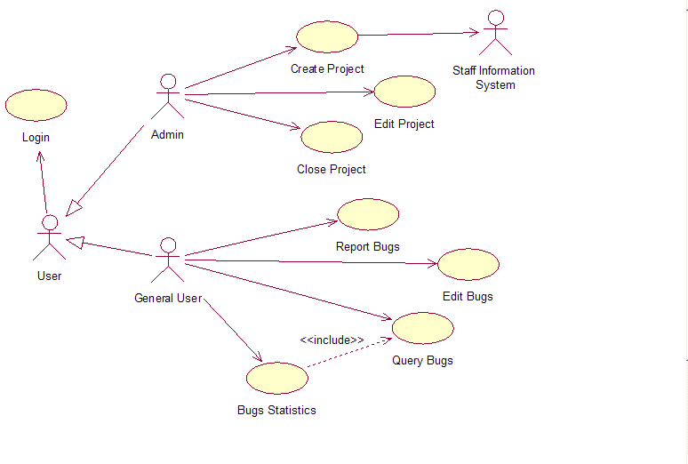

Architecture & Bill of Materials

Seq | Item | Qty | Functional Description | Vendor/ Manufacturer | Product  Name | Version | Part  No. | Purchase  Reuse  Upgrade | Standard  (Y/N) | CR  #* | Remark
1 | Server | High | Provide database service, response all the request from the clients | IBM, America | IBM Server Star | 1.0 | 10001 | R | Y | 2 | At least one
2 | Client PC | Middle | For different users to browse and develop, connect to service to get services. | IBM, America | IBM  Adapt Star | 1.0 | 10002 | R | Y | 1 | At least 5
3 | Switch | High | For all the computers in the group to connect together | Cisco, America | Cisco Switch 2153 | 2.0 | 10003 | R | Y | 2 | Just one
4 | Dual-Twister Wire | Low | To connect the PC to network | Legend, China | EtherWan E190560 CSA | ------ | 10004 | P | Y | 1 | Purchase more than required. Reserve the left,
5 | Operation System | High | Platform to develop system | Microsoft, America | Windows 2000 plus Service Pack 3 | 2000 Professional | 10005 | U | N | 3
6 | UML tools | Middle | Use to design system | IBM Rational, America | Rational Rose | 2002 | 10006 | R | Y | 2
7 | Develop Environment | Middle | Integrated develop environment to develop system. | IBM, America | IBM Eclipse WebSphere | 5.0 | 10007 | R | Y | 4
8 | Database | High | To store data, and provide the service for all the requires from client | IBM,  America | IBM DB2 | Enterprise Edition 8.1 | 10008 | P | Y | 3
9 | Manage Tool | Middle | To monitor the process of the project | Microsoft, America | Microsoft Project | 2002 Edition | 10009 | P | Y | 1
10 | Office Tools | Middle | To edit documents, table, etc. | Microsoft, America | Microsoft Office | 2002 Edition | 10010 | R | Y | 1
* If not a standard, indicates Standards Change Request #

User Interface

Login interface
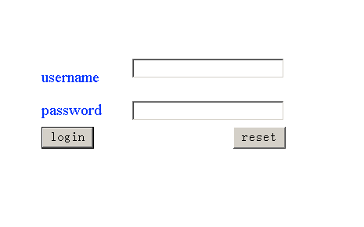

After a user is login
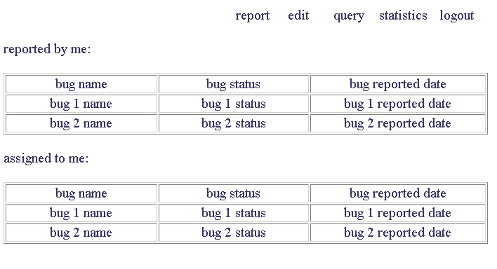

Administrator operation interface
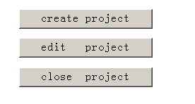

Project create and edit form

Team member authority and role assign form
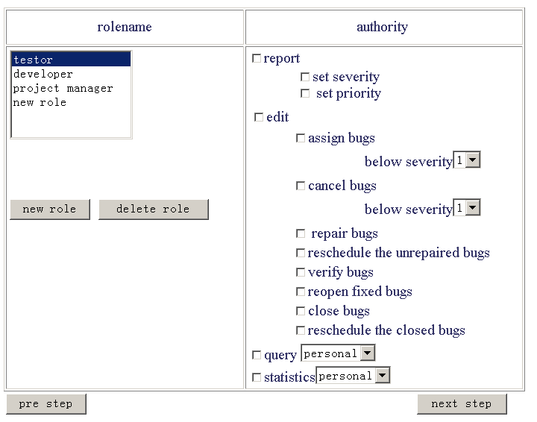

Bug report form
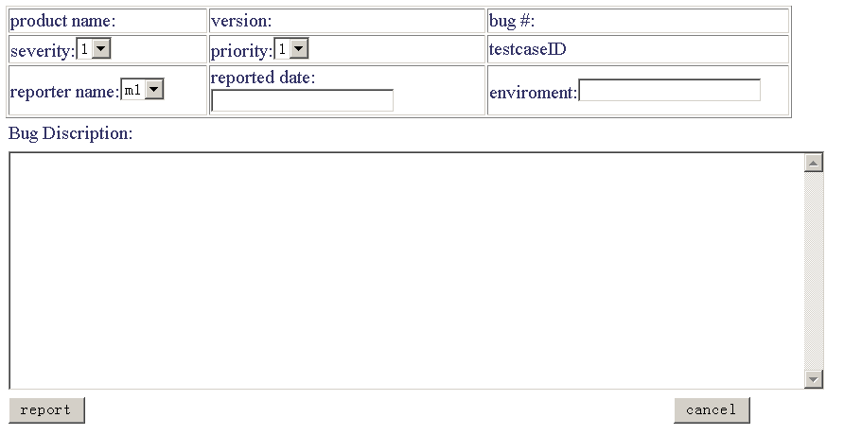

Bug edit form
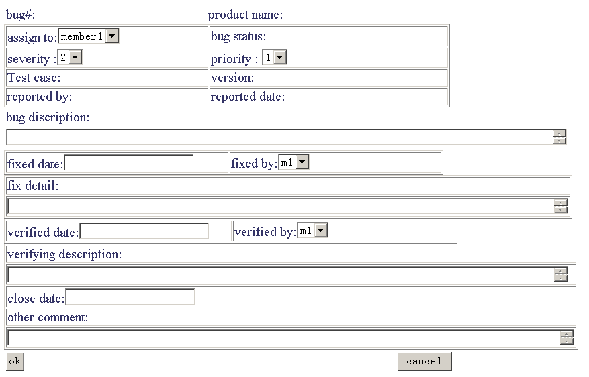
- Requirements Traceability
In phase of BTS developing, we will make three modules: Use-case Module, Analysis Module, and Design Module, so there exists the traceability among those modules
In UML, we describe this in the following ways:
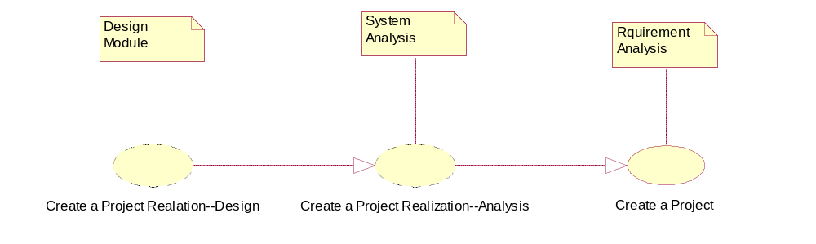
- Build/Buy/Reuse Rationale

Reuse Criteria
There are some components that we can reuse in this BTS. For instance, use-case Query Bugs and use-case Bugs Statistics include some same component, so we decide to reuse use-case Query Bugs, follows list the Considerations Matrix.
Use-case to reuse | Considerations | Comments/Observations
Query Bugs | Product Technical Considerations | We use SQL to realize this module, and It is not difficult
Query Bugs | Project Management Considerations | An important component In any system
Query Bugs | Deployment, Operations, and Maintenance Considerations | We choose IBM DB2 products, it can support this function well
Query Bugs | Business Considerations | Every company buy our software will think it a basic function and think it indispensable
Query Bugs | Financial Considerations | It will not cost much
Bug Statistics in the BTS and any other project which concerns about Database query operation can reuse this module
Edit Project | Product Technical Considerations | We use XML technique to fulfill this tasks, which is not difficult
Edit Project | Project Management Considerations | Give users a graphic interface, which is very important
Edit Project | Deployment, Operations, and Maintenance Considerations | Easy to maintain, everyone who have HTML working experience manage that
Edit Project | Business Considerations | It will help make our product a best seller.
Edit Project | Financial Considerations | It will not cost much
Report Bugs, Edit Bugs in BTS and any other project which concerns about GUI can refer to this component
In UML, we describe this in the following ways:
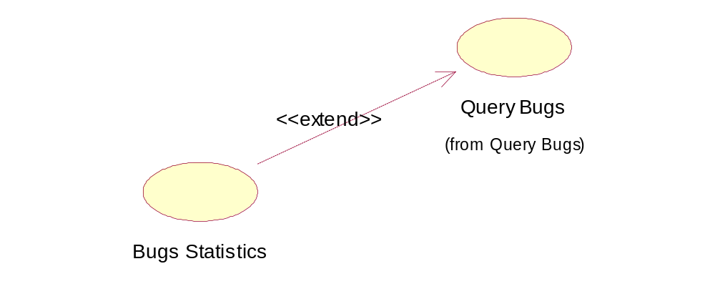

Rationale
We only build/buy/reuse those components which are commonly used and which can be transferred to other system easily.
- Requirements Dependencies
Among the function we required, we found some of the system requirement are depend on each other, for instance, we have a function that let user to query about the bugs, and another function to show statistics. Actually, we know that doing statistics are base on the query, so these two requirements are international.

Here I give a list to show dependencies between the requirements, (we describe the requirements in the form of use-case)
Requirement A | Requirement B | Dependency
Query Bugs | Bugs Statistics | As has mentioned above, use-case Query Bugs extends to use-case Bugs Statistics, they have the same component called search bugs in the database.
Create Project | Edit Project | We use use-case Create Project to initiate a project, but more often then not, we needs to modify it. So we need another use-case Edit Project, but these two use-cases have some form or attributes that are overlapped. Some basic operations are same in these two use-cases.
Report Bugs | Edit Bugs | As is same to the Create Project and Edit Project, there are dependencies between Report Bugs and Edit Bugs. But not like the above one concentrate on the attribute of the Project, this time, we focus on the Bugs attributes and states.
In UML, we describe this in the use-case diagram.
